*Analyzes how Tala leverages Big Data & Machine Learning*

**Assignment**

**6**

A6

ALY6060 Decision Support & Business Intelligence

Assignment 6 – Signature Assessment

**PREPERATION:**

By:

Akshay Kirit Kalavadia

John DiSessa

Tianyu Ouyang

Szuyun Hao

For: Professor Ellis

On: July 2nd, 2022

**Introduction**

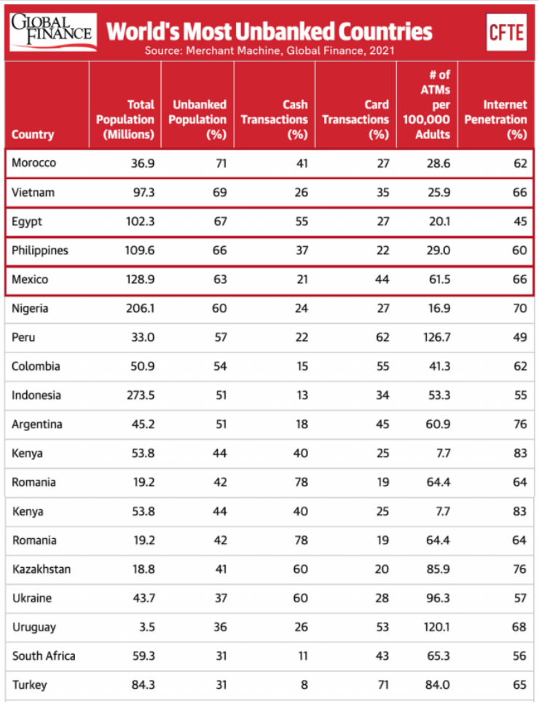Tala is a data science company that provides financial services through its mobile app. It was founded in 2011 by Shivani Siroya, who used to be an investment banking analyst. Shivani discovered that many customers she knew during her previous jobs were creditworthy but lacked immediate access to credit and quick loans. Moreover, over 2 billion people have limited access to financial services and working capital, per World Bank statistics. Therefore, Shivani decided to establish a company that could meet the needs of marginalized people. Tala has more than $350 million in investment and serves millions of customers worldwide who have been overlooked by traditional financial institutions (Tala, n.d.). They provide micro-loans ranging from $10 to $500 in emerging markets (Kene-Okafor, 2021). Tala has introduced data analytics , Artificial Intelligence (AI) and Business Intelligence (BI) to their business. With the help of AI and BI, Tala makes better business decisions and offers low-income individuals the ideal products.

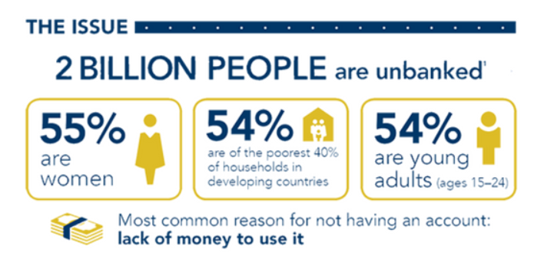

Tala has built up a robust data analytics culture. The company performs analytics on a daily basis to make business decisions and treat data as an asset for everyone to share. Their Data Analysis team is guided by Danny Salinas, the Director Of Analytics of the company. To enhance data literacy, Tala also holds weekly SQL courses for employees to attend and master their SQL abilities. Relevant data-related courses are held frequently so that Tala ensures their employees are more strategic and familiar with how data works. The team is responsible for creating insightful analyses that aid management decision-making, improve performance, elevate productivity, identify performance outliers and research the root cause of any potential performance changes (Tala, n.d.).

**Industry 4.0**

The Fourth Industrial Revolution, or Industry 4.0, conceptualizes rapid change to technology, industries, and societal patterns and processes in the 21st century due to increasing inter-connectivity and smart automation (Gazzaneo et al., 2019). It is featured with four aspects. First is the interconnection. The connection isn’t merely between people, but emphasizes that different kinds of machines, sensors or devices can connect and communicate with people by the internet, thus, everything is linked with each other. The second one is information transparency, which implies that the manufacturing process should be transparent for people to make proper decisions. The third one is technological assistance. Those systems are able to help people with dangerous tasks. The last one is decentralized decisions. The cyber physical system is conscious to make its own decisions, which is a relatively higher level of AI.

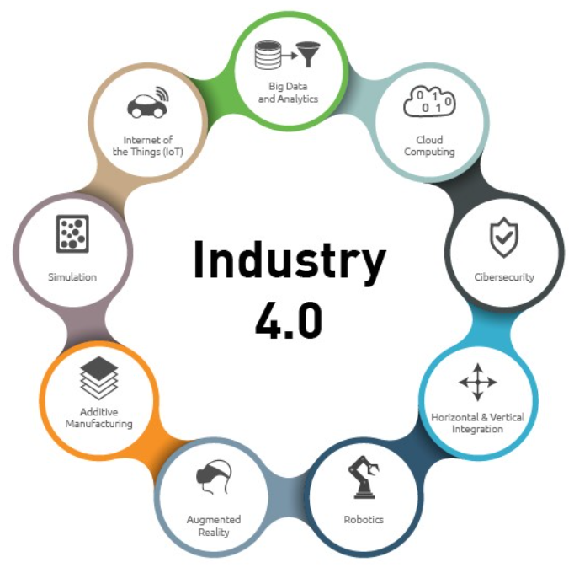

Many companies are forced to adapt to these changes or else operate at a disadvantage to companies who can offer technologically advanced products or be able to interpret and make decisions based on real-time big data. Perhaps there is no better example of a company using big data in real-time than Tala. Traditional banks give everyone credit scores based on their payment history, amount owed, credit age, account mix, and credit inquiries. The problem with this system is that it punishes underprivileged people around the world from benefiting their lives with credit. They can’t take out loans to invest in housing, transportation, or education since they are deemed “too risky” by traditional banks since they lack up-front capital, have low wages, or lack a credit history. Tala uses big data to evaluate people’s credit worthiness using other factors. Tala has created a proprietary credit evaluation algorithm that uses machine learning to evaluate a customer’s routine habits. Their texts, calls, location, social media use, app usage, utility bills, etc. can all be more indicative of credit worthiness than a credit score based on only 5 metrics. Their app tracks 10,000 data points for each customer and is able to estimate a customer’s ability to repay within seconds.

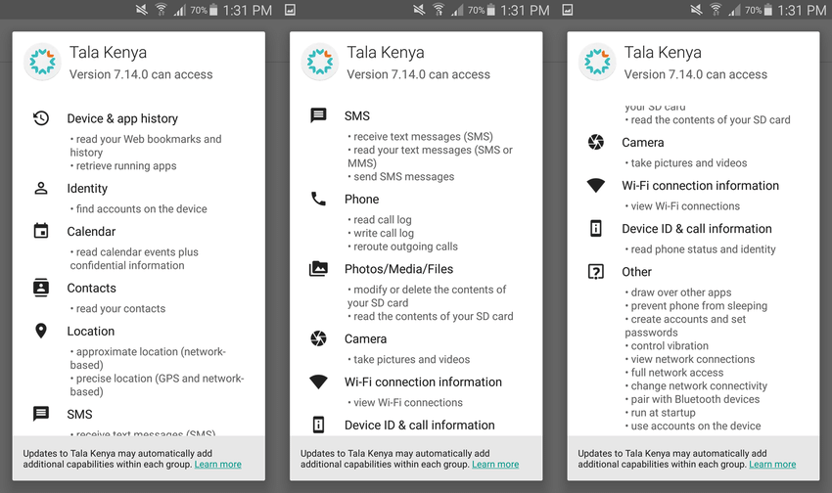

For example, nighttime calls cost more than daytime calls so if a customer conducts more nighttime calls, it can signal they have more money and are a better credit risk. If a customer communicates regularly (more than 5 minutes) with more than 20 people, it can show their have a strong social network which improves their credit risk. If more than half of their contacts are organized with both first and last names, this can signal their attention to detail and improves their credit risk. Those who play puzzle games are likely to be better customers than those who play violent games. Those who have fewer than 5 social media apps on their phones are likely to be better customers than those who have many social media apps. They aggregated thousands of data points on thousands of people and identified correlations and trends between human behavior and credit risk. If someone is not approved the first time, they can keep the app on their phone. Tala’s algorithm monitors their behavior, and if behavior improves, they can immediately become eligible for a loan. Tala is able to leverage their data and network effects in order to lead the micro-loan industry. With each new user, Tala can improve their credit evaluation accuracy by identifying new behaviors or improving the accuracy for existing ones. New entrants would be at a disadvantage since they would be competing against Tala without Tala’s accurate and robust database. As more users have positive experiences, they will attract more customers. Having more customers increases the amount of data and provides a constant positive feedback loop to continuously improve Tala’s services. Millions of people around the world would have previously been incapable of taking loans if not for Industry 4.0. The technological advancements allowed Tala to track thousands of data points for each customer, constantly monitor millions of customers in real-time, and use artificial intelligence to channel this data into useful business applications while also improving the livelihood of marginalized people.

**Tala Supports Global Need**

Due to the COVID-19 pandemic, communities and small businesses all over the world faced difficult situations. Shutdowns have wreaked havoc on disadvantaged populations in emerging markets. Tala created the COVID-19 Rebuild Fund in order to aid small companies that provide crucial services to their communities.

Tala's cutting-edge infrastructure and technology make sure that all donations go directly to those in need, with no fees, commissions, or hassles for the recipients. The Rebuild Fund is only getting started. Tala is right now assessing joint venture possibilities and new strategies to help consumers and their communities by delivering useful products and resources.Tala has taken initiatives to provide these services in Kenya, Philippines and Mexico. They have been successful in their initiatives and have ongoing missions in fulfilling the global needs.

**Conclusion**

Tala is one of the best examples of a company who leverages big data, machine learning, artificial intelligence, and interconnectivity in order to improve the lives of people in emerging markets. Tala determined that people’s behaviors and habits are indicative of credit worthiness. Tala can improve the lives of 2 billion people around the world, who don’t have access to banks or loans, by allowing them to take out loans for housing, transportation, or education. Their machine learning algorithm constantly assesses new data points so that it continually improves in order to offer more people more accurate risk-associated loans.

References

Tala. (n.d.). *TALA Reporting & Data Analyst*. STARTUP.JOBS. Retrieved June 25, 2022, from <https://startup.jobs/reporting-data-analyst-talamobile-3102055>

Kene-Okafor, T. (2021, October 14). *TechCrunch is part of the Yahoo family of brands*. TechCrunch+. Retrieved June 25, 2022, from <https://techcrunch.com/2021/10/14/tala-grabs-145m-to-offer-more-financial-services-in-emerging-markets/>

Gazzaneo, Lucia; Padovano, Antonio; & Umbrello, Steven. (2019). "Designing Smart Operator 4.0 for Human Values: A Value Sensitive Design Approach". Procedia Manufacturing. International Conference on Industry 4.0 and Smart Manufacturing (ISM 2019). 42: 219–226.

“What Is Industry 4.0-the Industrial Internet of Things (IIOT)?” *What Is Industry 4.0? | The Industrial Internet of Things | Epicor U.S.*, https://www.epicor.com/en-us/blog/learn/what-is-industry-4-0/.

“How Tala Works in Credit Score.” *SlideShare a Scribd Company*, https://www.slideshare.net/NguyenGiang102/how-tala-works-in-credit-score.

Tala. (2020, April 1). *Tala launches COVID-19 Rebuild Fund to support vulnerable communities*. Tala. Retrieved June 30, 2022, from https://tala.co/blog/2020/04/01/tala-launches-covid-19-rebuild-fund-to-support-vulnerable-communities/